**Lab Exercise 1**

**Name:** **Mohamad Haziq Zikry Bin Mohammad Razak**

**Matric No: A20EC0079**

**Section: 8**

Please answer the questions. Any picture format answer is not accepted

1.

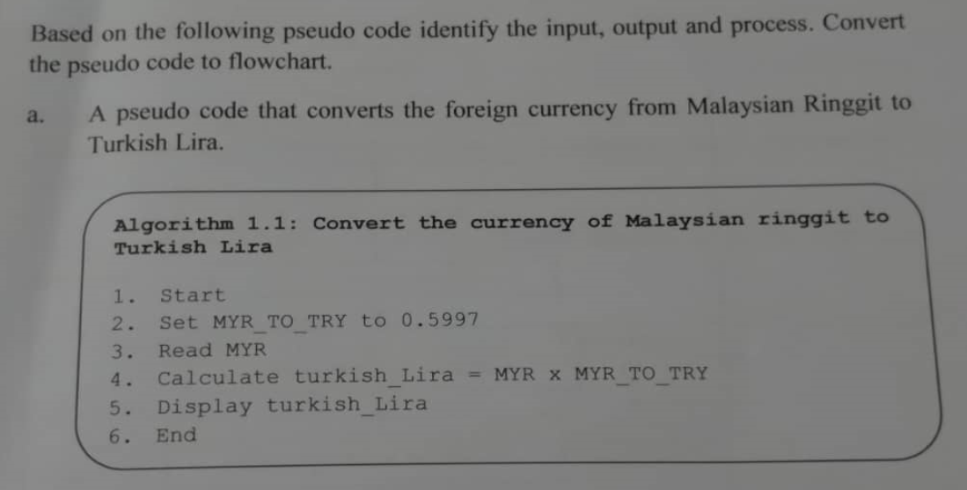

Input: MYR

Output: turkish_Lira

Process: Set MYR_TO_TRY to 0.5997, Calculate turkish_Lira = MYR x MYR_TO_TRY

**Flowchart**

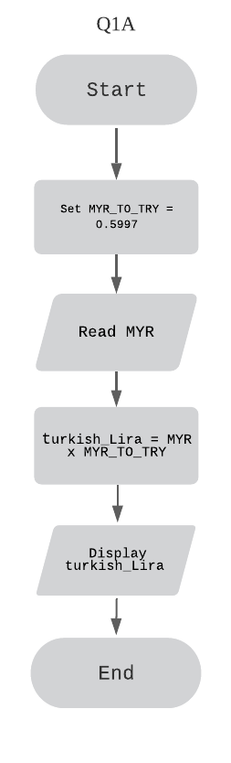

b. 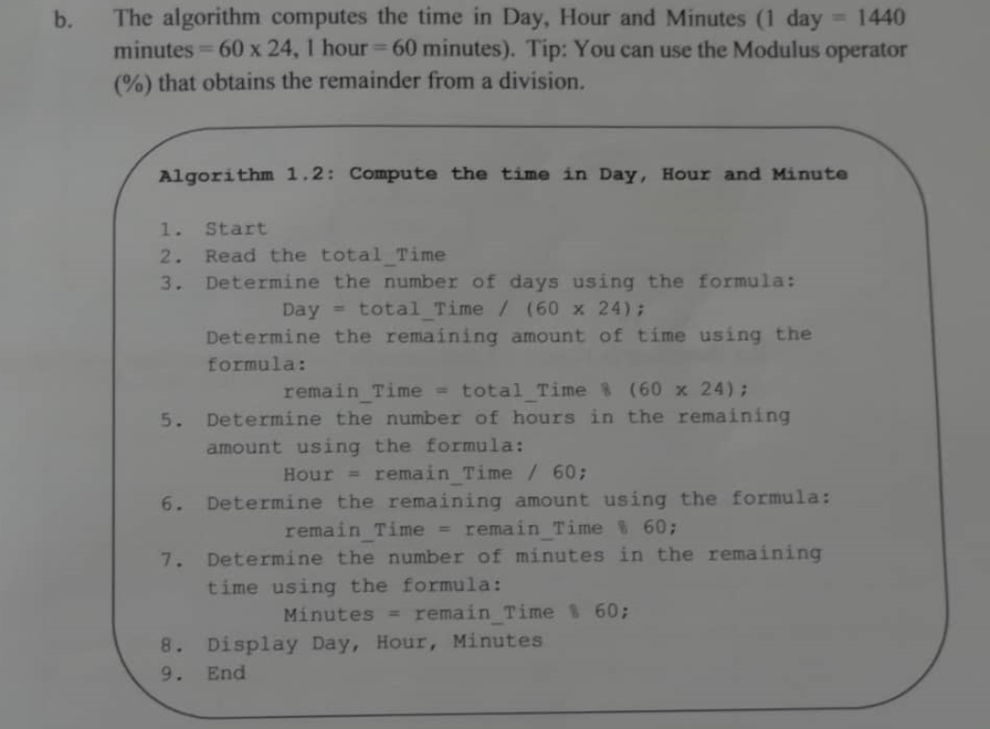

Input: total_Time

Output: Day, Hour, Minutes

Process: Calculate Day= total_Time / (60 x 24), Calculate remain_Time = total_Time % (60 x 24) , Calculate Hour = remain_Time / 60 , Calculate remain_Time = remain_Time % 60 , Calculate Minutes = remain_Time % 60

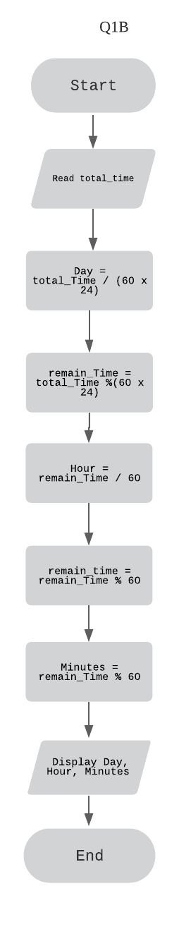**Flowchart**

2.

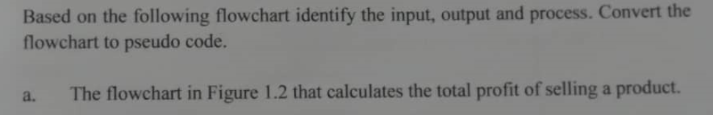

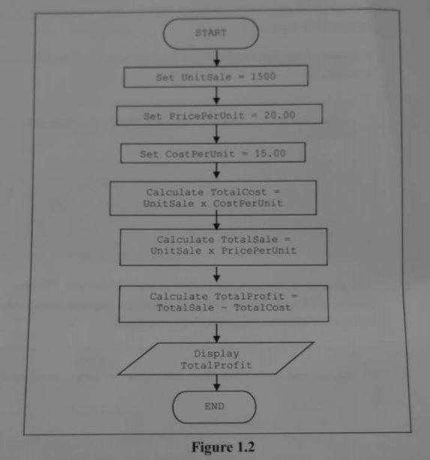

Input: None

Output: TotalProfit

Process: Set UnitSale = 1500 ,Set PricePerUnit = 20.00 ,Set CostPerUnit = 15.00, Calculate TotalCost = UnitSale x CostPerUnit , Calculate TotalSale = UnitSale x PricePerUnit , Calculate TotalProfit = TotalSale – TotalCost

**Pseudocode**

1. Start
2. Set UnitSale = 1500 , PricePerUnit = 20.00 , CostPerUnit = 15.00
3. Calculate TotalCost = UnitSale x CostPerUnit
4. Calculate TotalSale = UnitSale x PricePerUnit
5. Calculate TotalProfit = TotalSale – TotalCost
6. Display TotalProfit
7. End

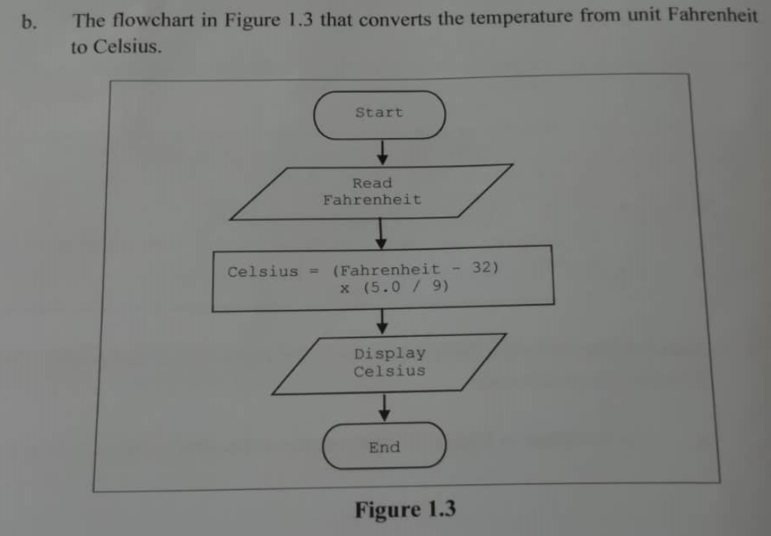

Input: Fahrenheit

Output: Celsius

Process: Celsius = (Fahrenheit – 32) x (5.0 / 9)

**Pseudocode**

1. Start
2. Read Fahrenheit
3. Calculate Celsius = (Fahrenheit – 32) x (5.0 / 9)
4. Display Celsius
5. End

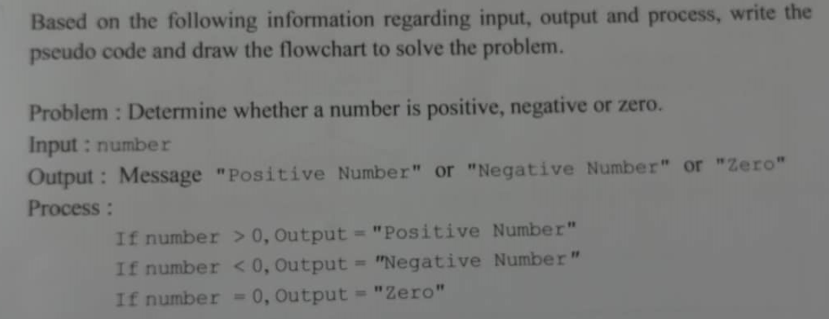3.

**Pseudocode**

1. Start
2. Read number
3. If number > than 0
   1. Display “Positive Number”
   2. Go to step 8
4. Else if number < than 0
   1. Display “Negative Number”
   2. Go to step 8
5. Else if number = than 0
   1. Display “Zero”
   2. Go to step 8
6. Else

Display “Invalid input!”

1. End if-else-if.
2. End

**Flowchart**

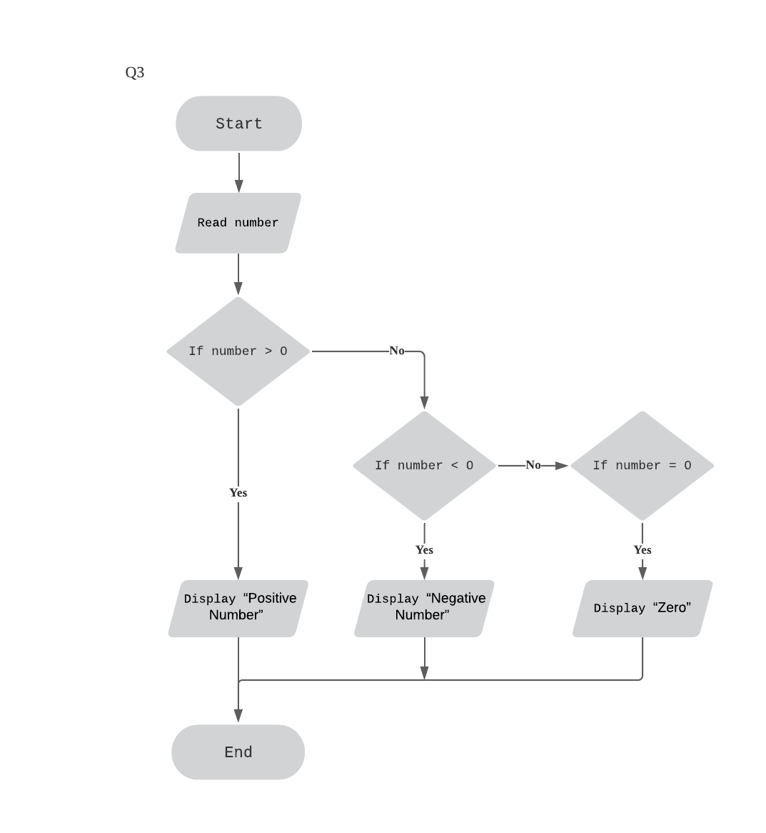

4.

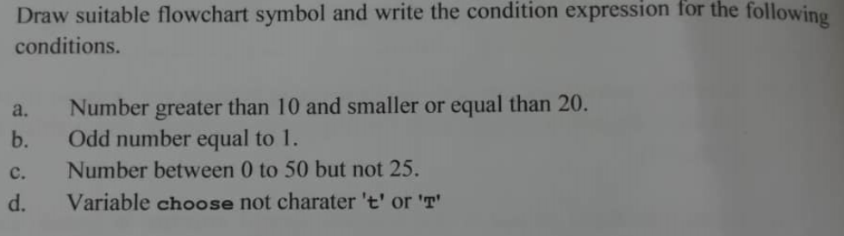

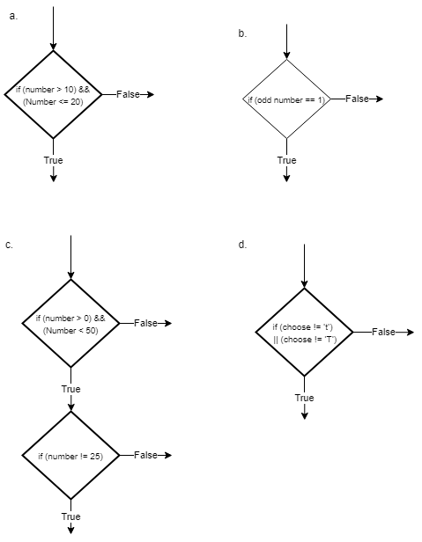

5.



**Trace Table**

|  |  |  |  |  |  |  |
| --- | --- | --- | --- | --- | --- | --- |
| UnitSale | PricePerUnit | CostPerUnit | TotalCost | TotalSale | TotalProfit | OUTPUT |
| 1500 | 20.00 | 15.00 |  |  |  |  |
|  |  |  | 22500 |  |  |  |
|  |  |  |  | 30000 |  |  |
|  |  |  |  |  | 7500 |  |
|  |  |  |  |  |  | 7500 |

Output: 7500

6.



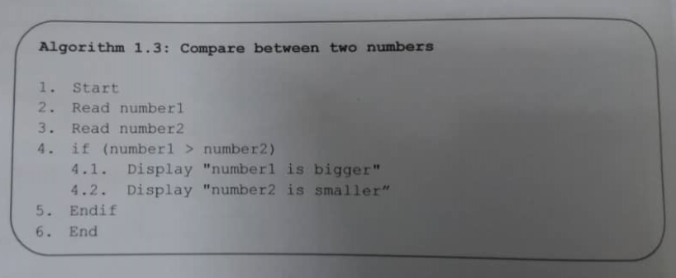

1. No, it does not give an output.

b. Pseudocode

1. Start
2. Read number1
3. Read number2
4. If number1 > number 2
   1. Display “number1 is bigger”
   2. Display “number2 is smaller”
   3. Go to step 9
5. Else if (number1 < number2)
   1. Display “number1 is smaller”
   2. Display “number2 is bigger”
   3. Go to step 9
6. Else if (number1 == number2)
   1. Display “number1 is equal to number2”
   2. Go to step 9
7. Else

7.1 Display ‘”invalid input!”

1. End if-else-if
2. End